# **Super Kong**

#### **1. Main Story**

The protagonist, **Infernok**, a descendant of the divine apes, was born from a thousand-year-old egg infused with the spiritual energy of heaven and earth.

On his journey home, he must traverse countless perilous lands, from dense jungles where demons lurk to dark dungeons filled with deadly traps. But the greatest challenge lies in the **Volcanic Lands**, where rivers of molten lava constantly flow, and mysterious creatures rise from the ashes.

With the weapons he collects and skills that grow stronger through each battle, only by overcoming all obstacles can he finally reach his village, where his kin eagerly await his return.

## **2.Game screen**

## 

**1.Mystic Forest**

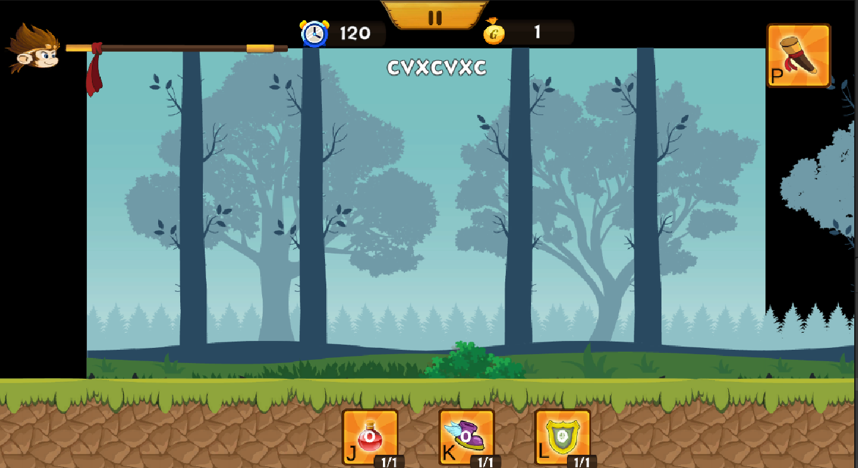

**2.Dark Cave**

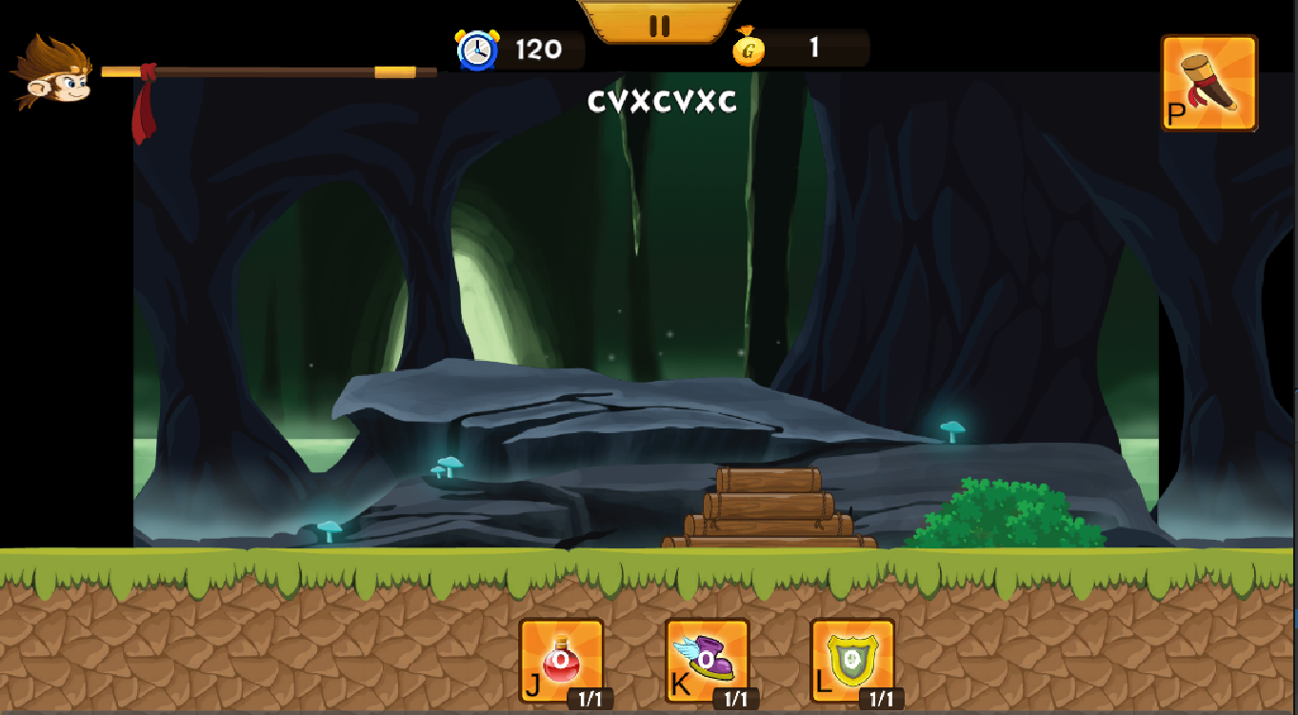

**3.Majestic Mountains and Forests**

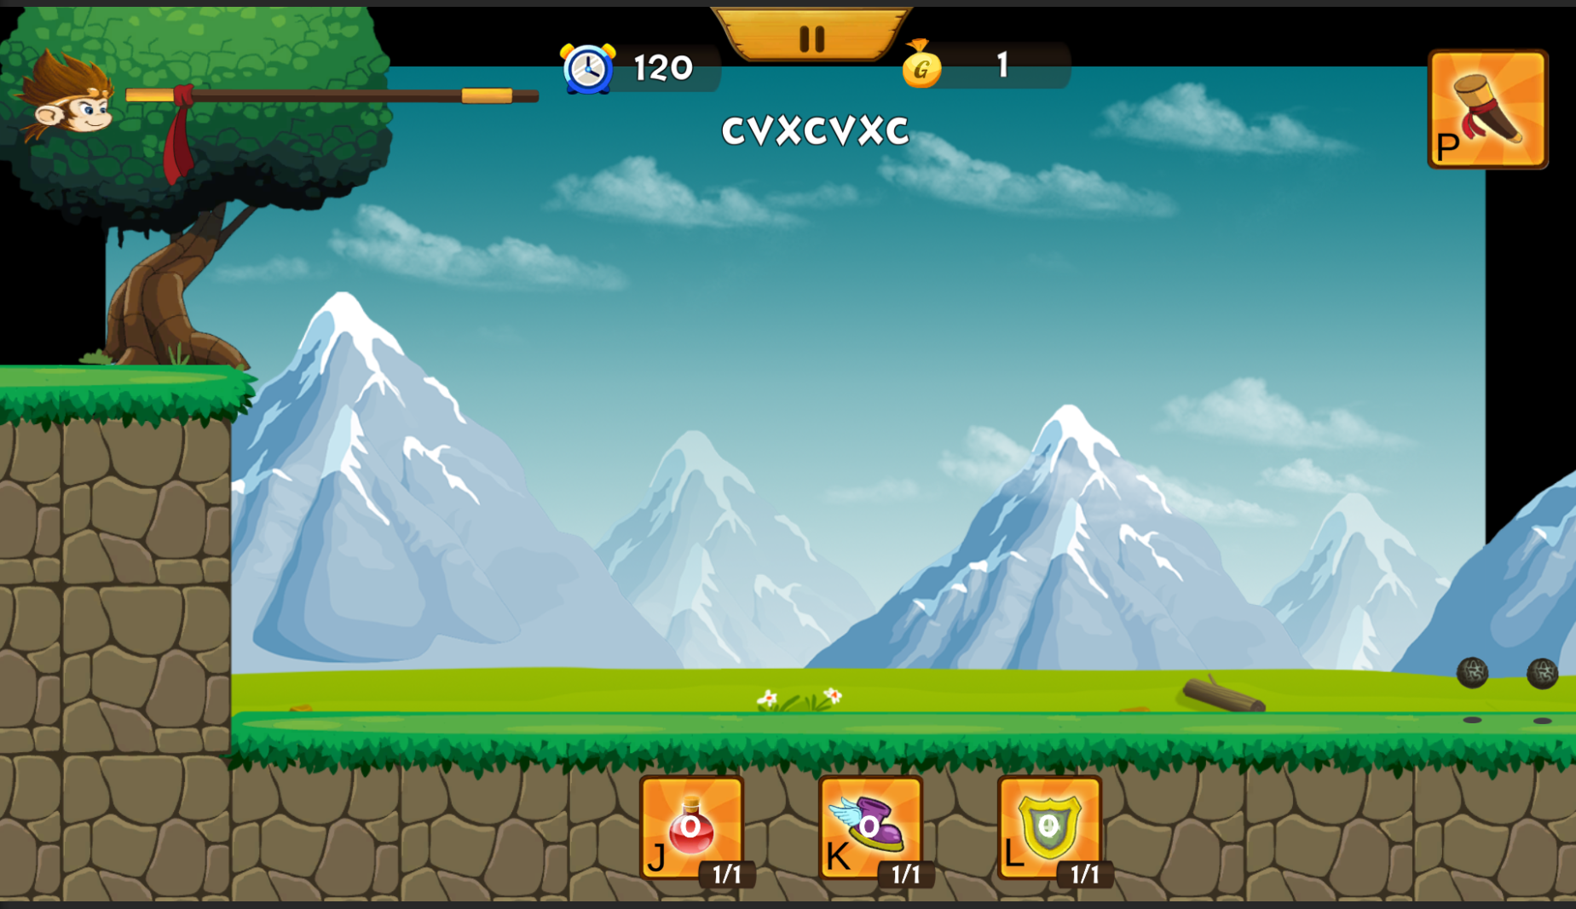

1. **Vùng Đất Băng Giá***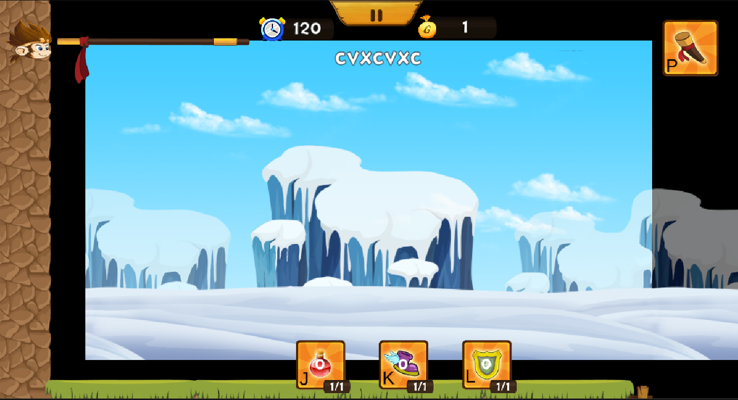*
2. **Vùng Đất Núi Lửa**

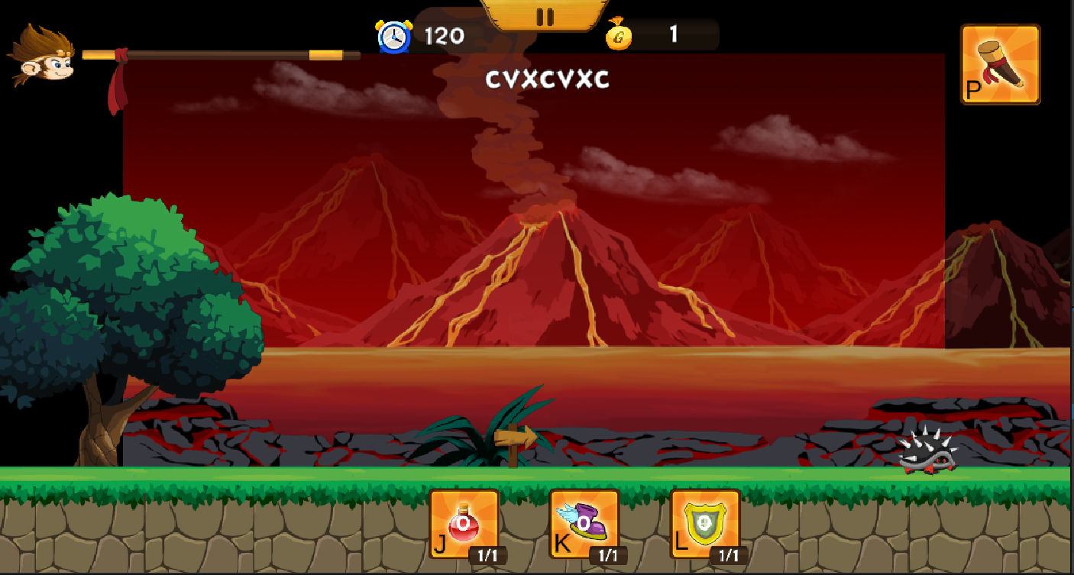

## **3. Asset others**

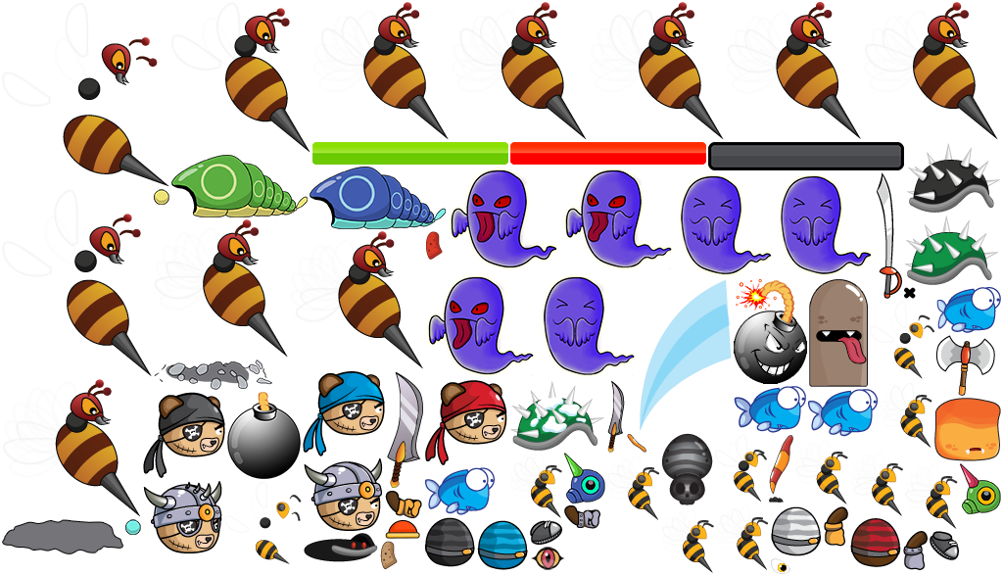

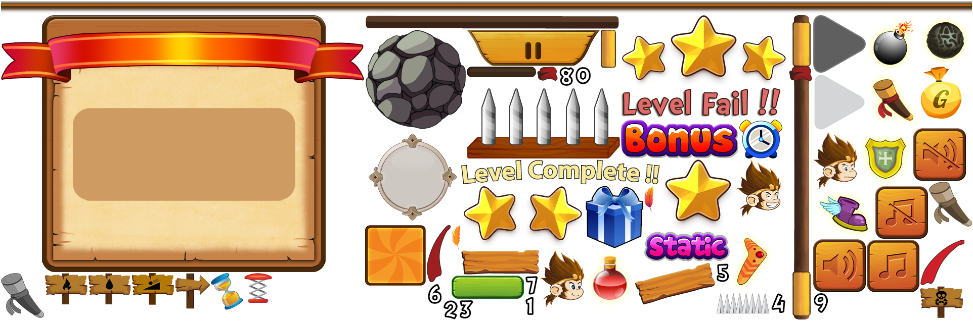

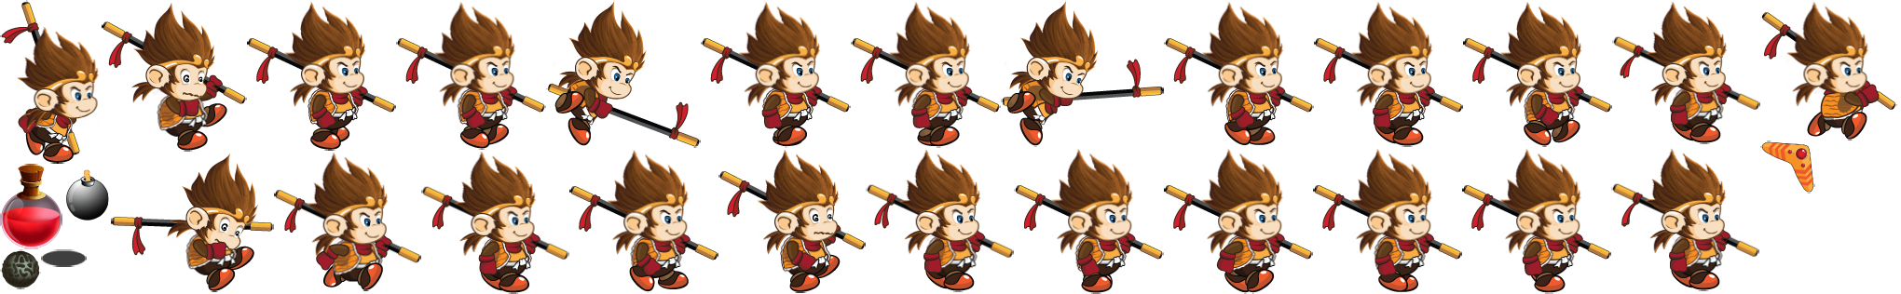

**

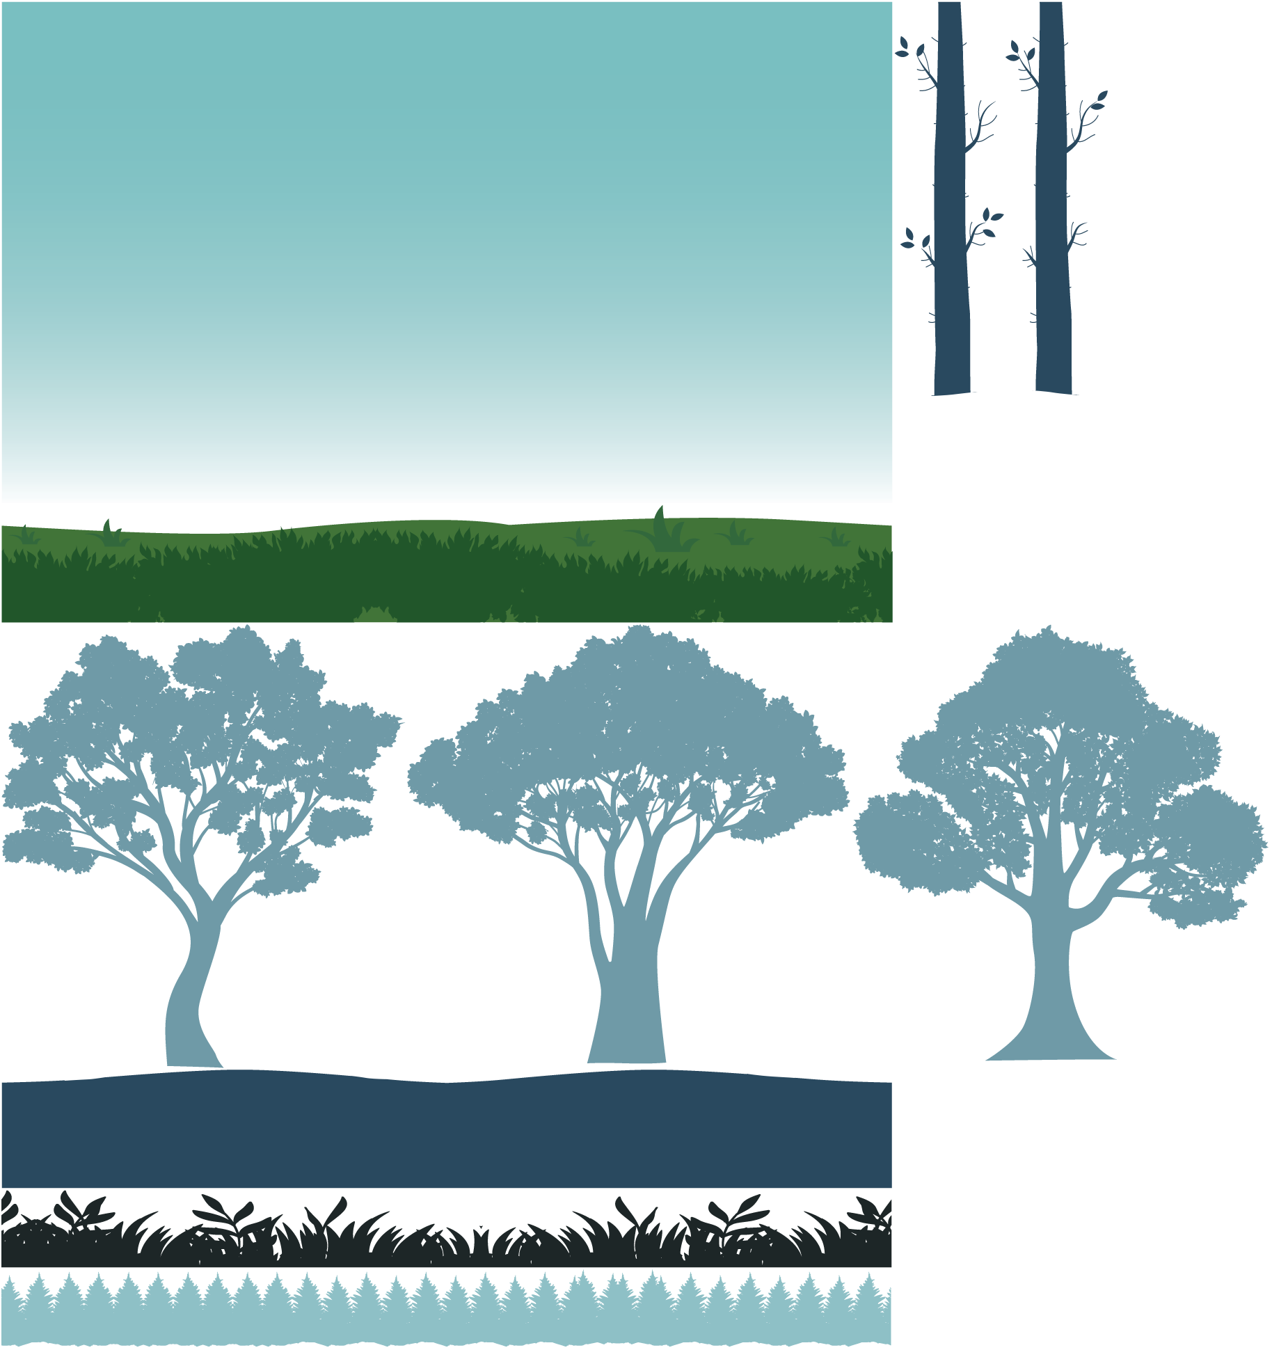

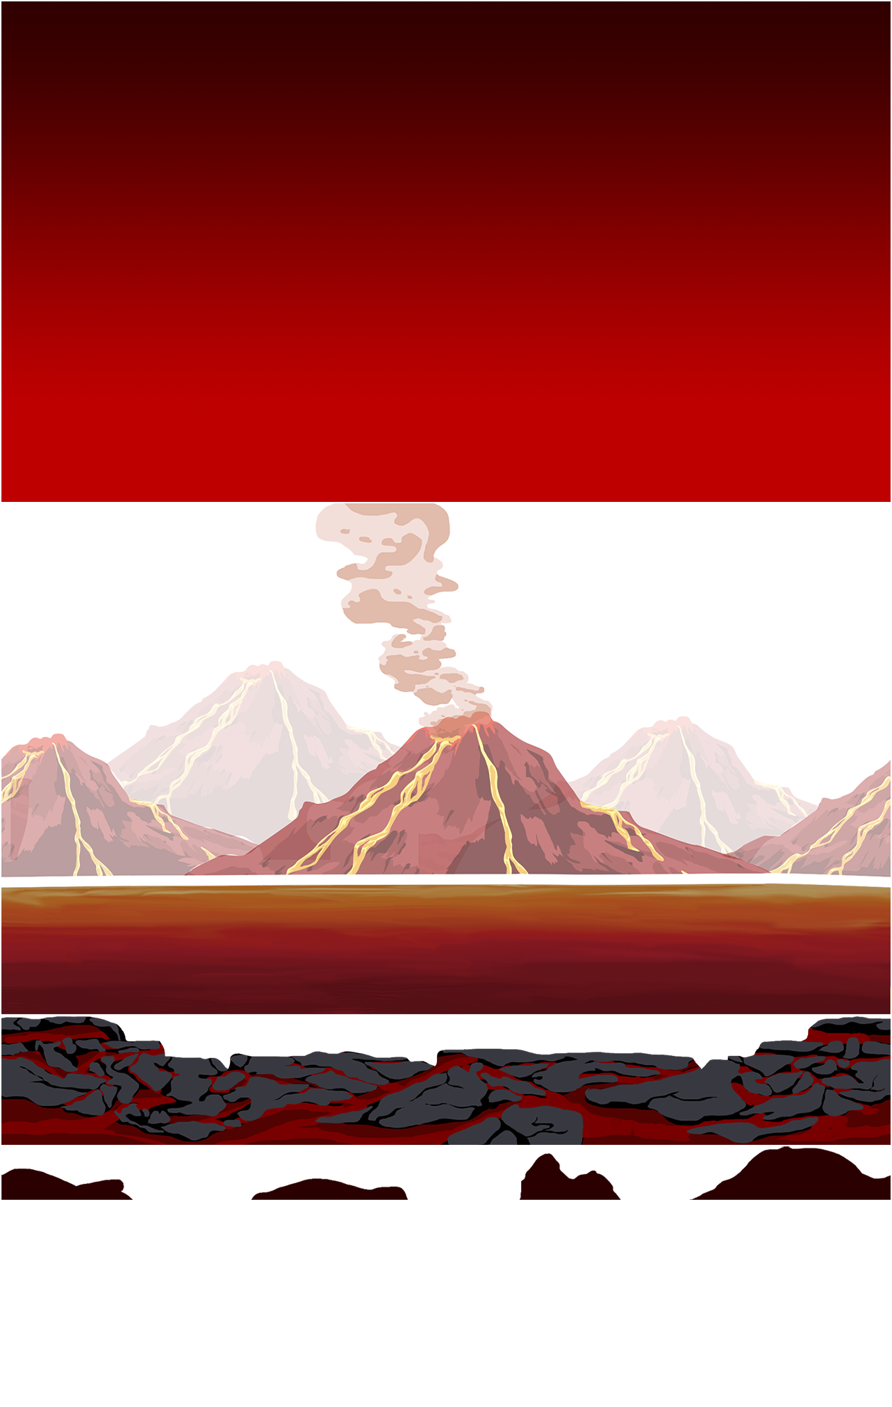

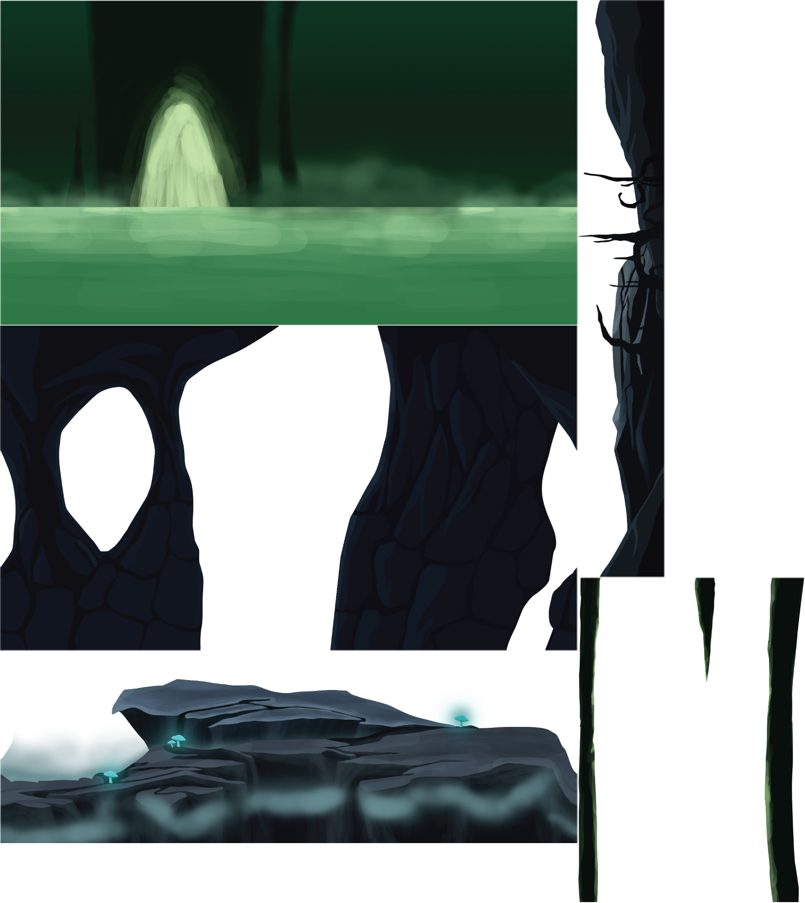

## **3. In-Game Elements**

* Control Mechanism
* A: move left
* D: move right
* Space: jump
* J: use healing skill
* K: use acceleration skill
* L: use shield skill
* P: Change weapon
* M: use to attack

**Mechanism**

· Attack items will be spammed in the map, players can collect and use them

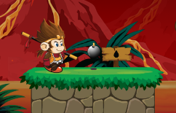

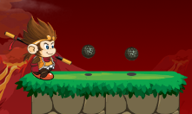

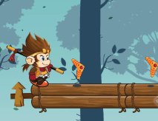

· Kill monsters to get a chance to receive coin bag

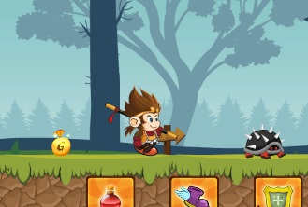

· Character's health will decrease when attacked by monsters or trapped

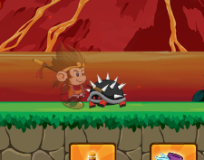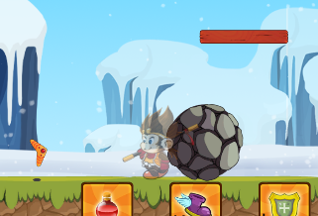

### **Công thức tính sát thương**

* Each item has its own damage stats.
  + Gậy
  + Damage :1
  + Bom 
  + Damage: 2
  + Rock
  + Damage: 1
  + Boomerang 
  + Damage: 1
* **Rewards System**
* Currency: Buy items, weapons from the store.
* **Equipment System**

Stick

Bomb

Rock

Boomerang

### **Chi Tiết Gameplay (Gameplay Features)**

* **Explore: The map gradually unlocks, allowing players to return to previous areas.**
* **Kill monsters: Kill monsters to gain points and money.**

### **(Character System)**

#### **Main character:**

**Skill** :

* + Melee (stick).

Range Weapon(bom, boomerang, rock).

* **Support Skill:**
  + Health 

Restores health at 5 HP

* + Shield 
  + In champion state, no blood loss
  + Shoe   
    Speed ​​up at level 9

#### **Monster:**

* Variety, difficulty increases with each level.

### **4. Storyline**

#### **Stage 1: The Enchanted Forest**

* **Setting:** A misty, silent forest filled with hidden dangers. Shadows conceal mysterious foes.
* **Objective:**
  + Learn the game mechanics: movement, attack, and item usage.
  + Defeat basic enemies (ferocious turtles, raging bees).
  + Collect support items to progress.
* **Outcome:** Meet NPCs and unlock the gateway to the next stage.

#### **Stage 2: The Dark Cavern**

* **Setting:** A damp, eerie cave lit by glowing mushrooms, concealing lurking dangers.
* **Objective:**
  + Escape the cave using collected items to fight off monsters.
  + Battle raging bees, armored turtles, and evade sudden spider ambushes.
* **Outcome:** Discover clues about the **Majestic Jungle**, a key location on the journey home.

#### **Stage 3: The Majestic Jungle**

* **Setting:** A dark, untamed wilderness filled with lurking dangers. Evil creatures roam, guarding the only path forward.
* **Objective:**
  + Defeat demons blocking the way while avoiding hazards like falling into the sea.
  + Collect power-up items to increase combat strength.
* **Outcome:** Overcome brutal challenges to locate the hidden portal leading to the next stage.

#### **Stage 4: The Frozen Lands**

* **Setting:** A frost-covered landscape with icy rivers. Enemies attack from both land and water.
* **Objective:**
  + Defeat demons and evade environmental dangers like freezing waters.
  + Gather essential items to prepare for the final battle.
* **Outcome:** Obtain a map leading to the final destination—the path home.

#### **Stage 5: The Volcanic Lands**

* **Setting:** A land engulfed by lava-covered mountains, shrouded in darkness and intensity.
* **Objective:** Defeat monsters along the path to survive.
* **Outcome:** Enter the **teleportation portal** and finally return home.